Chen Yidan Visiting Global Fellows
Global Education Opportunities
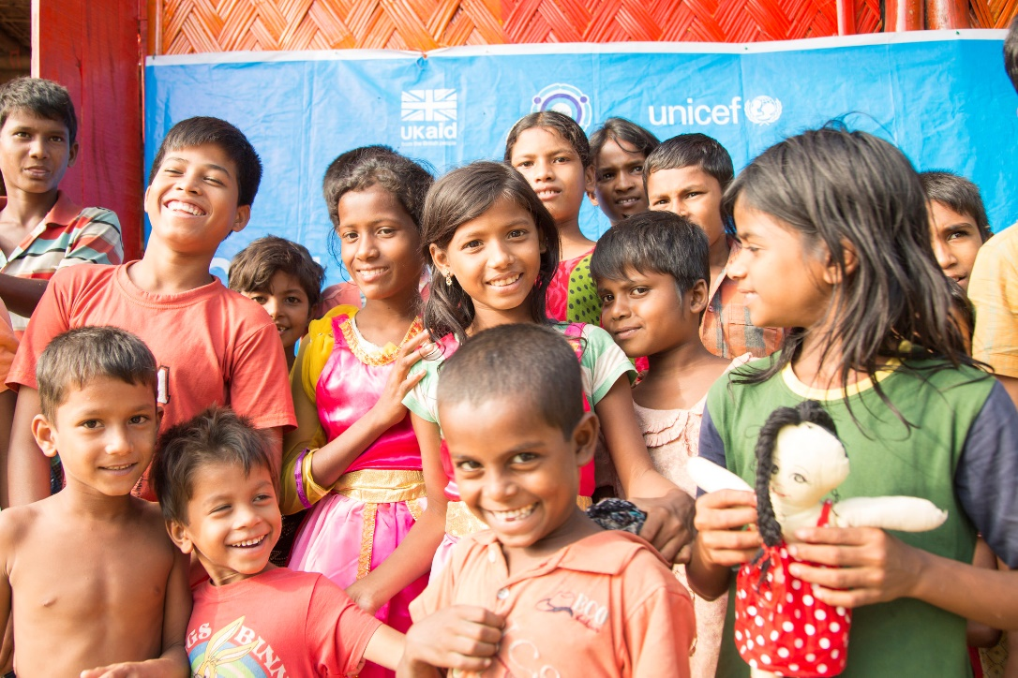


Website: https://globalfellows.gse.harvard.edu
Chen Yidan Visiting Global Fellows
Harvard Graduate School of Education
Email: globalfellows@gse.harvard.edu
Phone: 617-495-4201
Photo Credit: Rohingya children playing at a UNICE child-friendly space, supported by UK aid, inside Batukhalli refugee camp in Bangladesh by Anna Dubuid/DFIFis licensed under CC BY 2.0. Has been cropped.
Each semester, HGSE will bring international leaders of education to campus to teach 1-credit modules, provide public talks, and collaborate with HGSE community members. Learn from former Ministers of Education, founders of NGO's, and international scholars.
Visit our website for more details!

